CHAPTER 5
TESTS AND RESULTS
This chapter presents the practical outputs of the Smart Attendance System at https://tuhmbattendance.com/. The results are illustrated using the assembled hardware, student and teacher interfaces, the administrator dashboard, and downloaded attendance reports. Each screen is explained in terms of the selected function and the result visible to the user.

5.1 Test Setup and Hardware Results
The evaluation cohort consisted of 14 fifth-year Mechatronics students. Face registration/training was completed for these 14 classmates: their enrolled face representations formed the reference set used for attendance verification. This enrollment process should not be confused with training a new face-recognition model from scratch. The course roster and exported reports both contain the 14-student cohort.
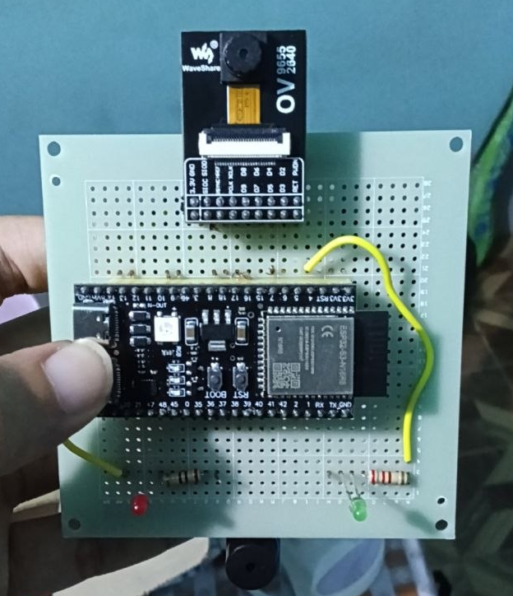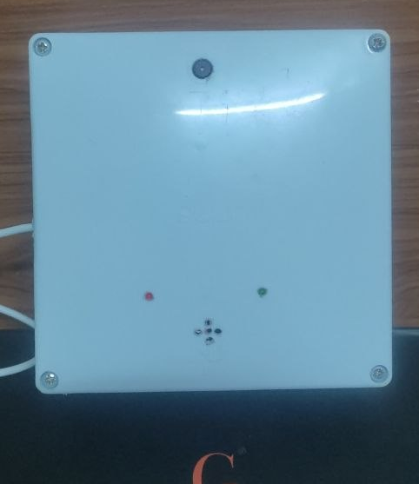
Figure 5.1 Attendance prototype: (a) internal assembly; (b) enclosed unit.
The ESP32-S3 controller, OV2640 camera, red and green indicators, and buzzer were assembled on a perforated board. The enclosure leaves the camera and feedback openings accessible while covering the electronics. The photographs document the completed construction; they do not constitute measured evidence of recognition accuracy, response time, or enclosure durability. The system was tested in a normal indoor classroom environment to verify the complete attendance process from face capture to attendance recording.

5.2 Login and Student Dashboard
The login screen accepts an email address and password. After authentication, the account role determines whether the student, teacher, or administrator portal is displayed. The preview buttons are labelled as sample-data demonstrations and are separate from the authenticated results presented in this chapter.
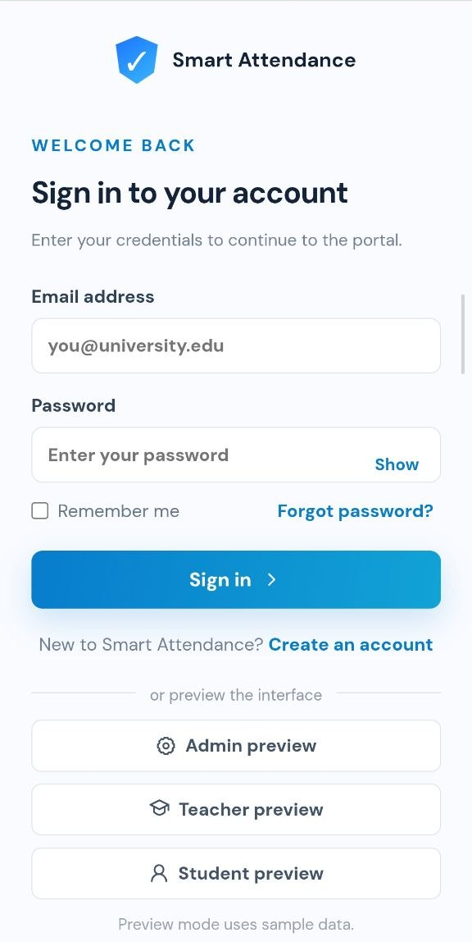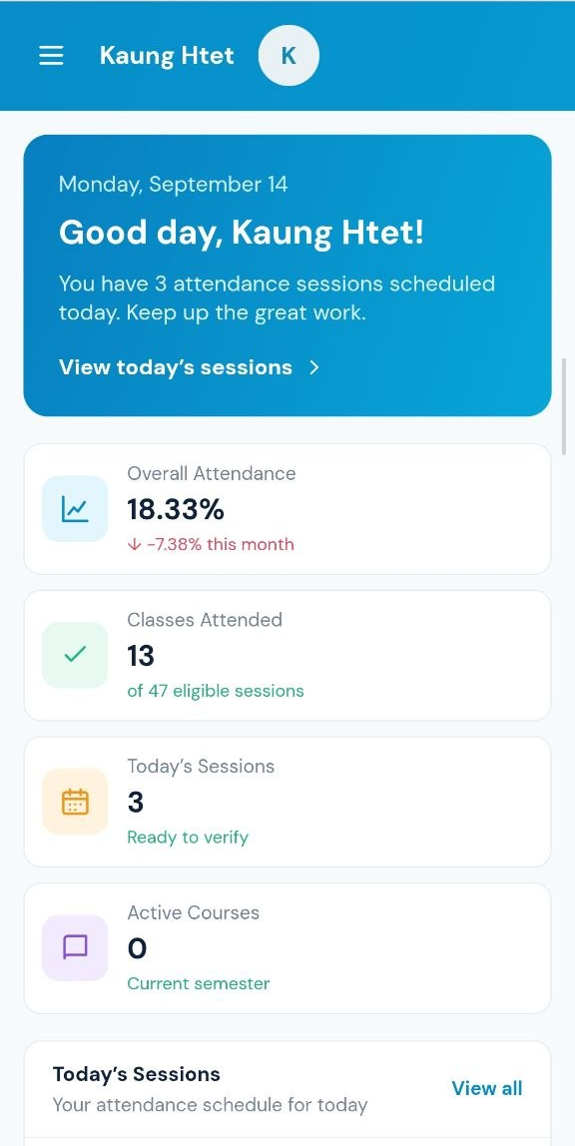
Figure 5.2 (a) Login interface; (b) authenticated student dashboard.
Login result. The supplied student and teacher screens show that the respective portals were reached. The clean login view is used here so that no password is disclosed.
Dashboard result. The student sees a greeting, overall attendance, attended and eligible sessions, today’s sessions, and active courses. “View today’s sessions” opens the session list. In this snapshot, the displayed overall attendance is 18.33%; this is an attendance statistic, not face-recognition accuracy. Interface and navigation result. The student dashboard was also examined to confirm that the main information could be accessed clearly after authentication. The interface presents attendance information using summary cards and separates the available functions into clearly identifiable sections.

5.3 Student Functions and Observed Results

5.3.1 Attendance Sessions and Scan Attendance
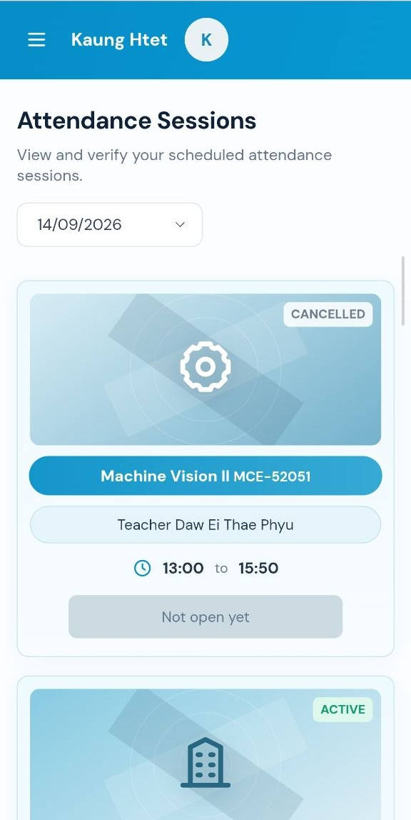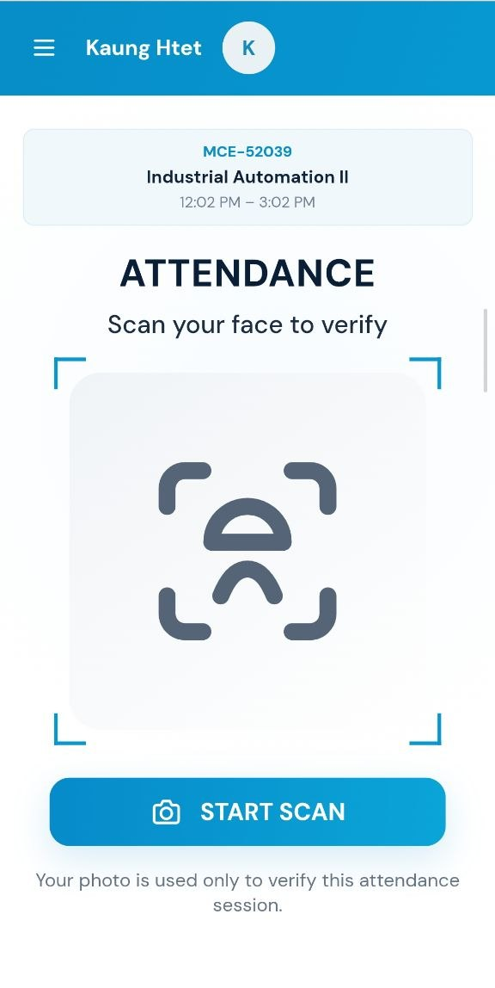
Figure 5.3 (a) Session list; (b) scan entry for the selected course.
Attendance Sessions. Selecting this function displays sessions for the chosen date. Each card identifies the course, teacher, time, and session status. The example includes a cancelled Machine Vision II session and an active session further down the list. A cancelled class is not an available attendance opportunity.
Scan Attendance. The selected Industrial Automation II session is shown with its course code and time window. Pressing “START SCAN” opens camera capture. Displaying the selected course before capture helps the student verify that the intended class is being recorded.
The date selector and session status guide the student to an appropriate class before verification. The capture screen then provides a direct link between the camera action and the selected attendance session. At this stage, selecting a session does not itself confirm attendance. The student must continue to camera capture and receive a verification response.

5.3.2 Camera Capture and Verification Result
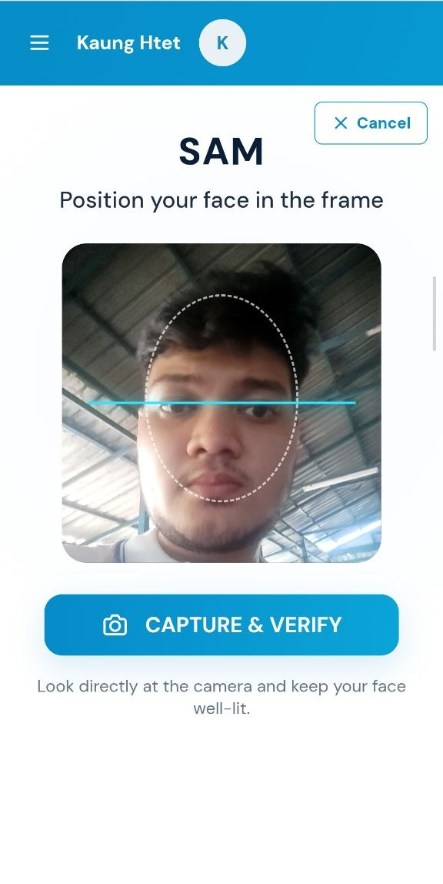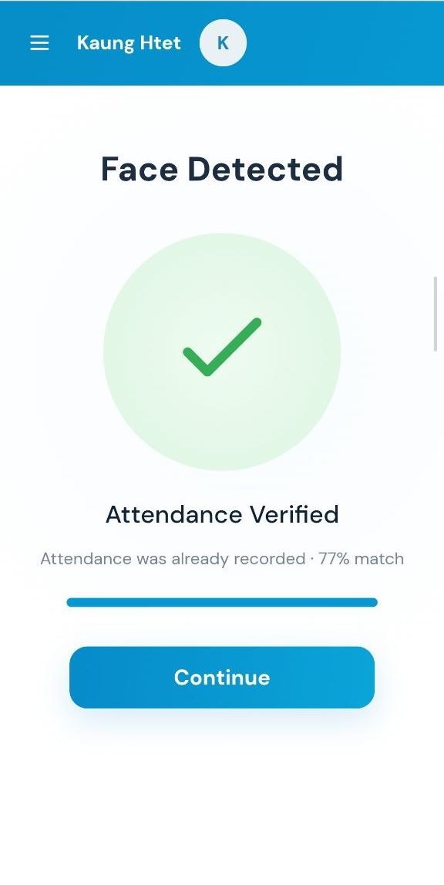
Figure 5.4 (a) Face capture; (b) verified, already-recorded response.
Capture operation. After camera access is allowed, the live image appears inside the face-position guide. The student faces the camera and selects “CAPTURE & VERIFY”; “Cancel” closes the capture operation.
Observed result. The returned screen displays “Attendance Verified” and “Attendance was already recorded · 77% match”. This confirms that this attempt was recognized as an already-recorded attendance, rather than showing a newly created record. The duplicate response gives feedback without asking the student to submit another attendance entry.
The 77% value is the similarity reported for this individual scan. It is not a 77% success rate for the 14-student cohort. A recognition-accuracy claim would require a separate set of labelled attempts, including successful and unsuccessful cases. The result screen combines a green confirmation symbol with a written message, allowing the student to understand the outcome without interpreting the similarity score alone. In this example, the “already recorded” message clarifies that attendance exists for the selected session.

5.3.3 Timetable and Courses
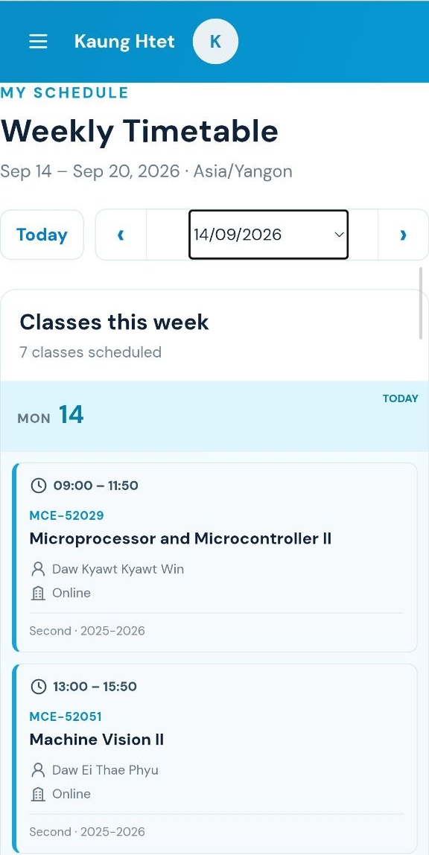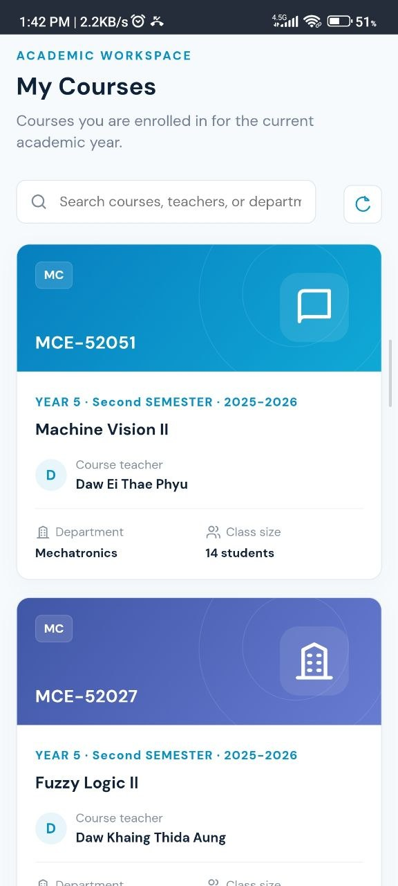
Figure 5.5 (a) Weekly timetable; (b) enrolled course cards.
Timetable. Selecting Timetable opens the weekly schedule. The student can move between weeks or return to today. Each entry shows the class time, course code and title, teacher, room, and academic period. The example displays the week of 14–20 September 2026.
Courses. Selecting Courses displays the student’s enrolled subjects. The cards identify the teacher, department, year, semester, academic year, and class size. A search field and refresh control are available. The Machine Vision II card shows a class size of 14 students, consistent with the evaluation cohort. The two views provide complementary academic information. The timetable shows when a class is scheduled, while the course page identifies the subject and its associated teacher. In the illustrated example, Machine Vision II appears in both views with the same course code, MCE-52051, and teacher name. This consistency allows the student to relate a scheduled lesson to an enrolled subject.

5.3.4 Profile and My Attendance
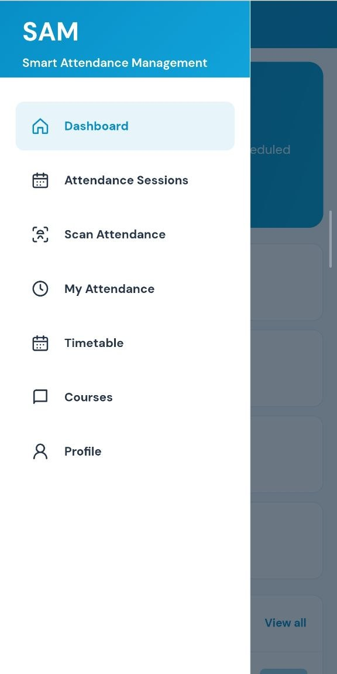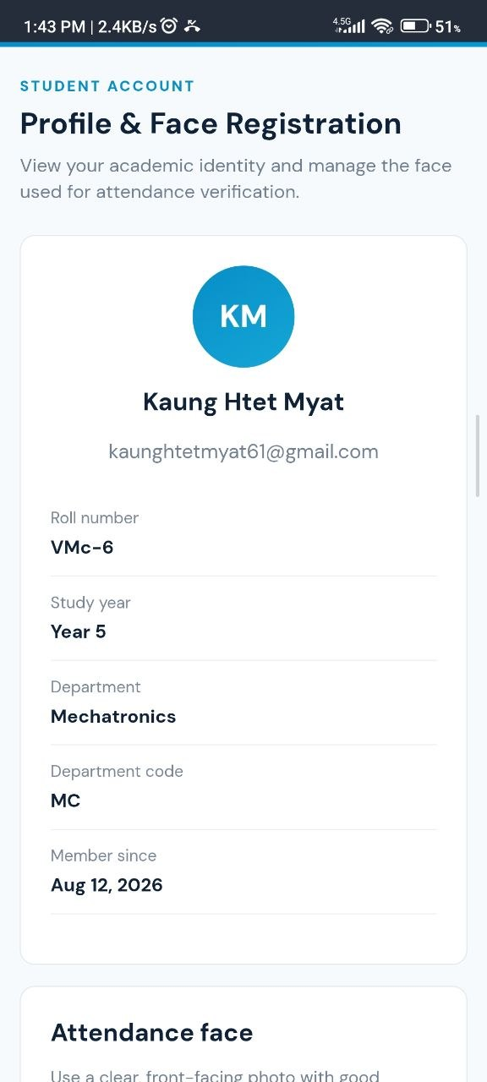
Figure 5.6 (a) Student navigation; (b) profile and face-registration page.
Profile. The student profile displays the account identity, roll number, study year, department, and membership date. The Attendance face section is used to manage the enrolled reference face for later verification. The example belongs to a fifth-year Mechatronics student in the test cohort.
My Attendance. This menu entry opens attendance history. The implemented view shows attendance rate, present and absent counts, eligible sessions, and recent records with course, date, time, status, and face-match score. Selecting “View” opens the record details. The navigation screenshot identifies the entry; a separate history-page screenshot was not included in the supplied evidence. The profile and attendance history serve different purposes within the student portal. The profile identifies the enrolled student, whereas attendance history describes participation in individual classes. In the example, the roll number, study year, and department provide academic context for reviewing the student’s records.

5.4 Teacher Functions and Observed Results
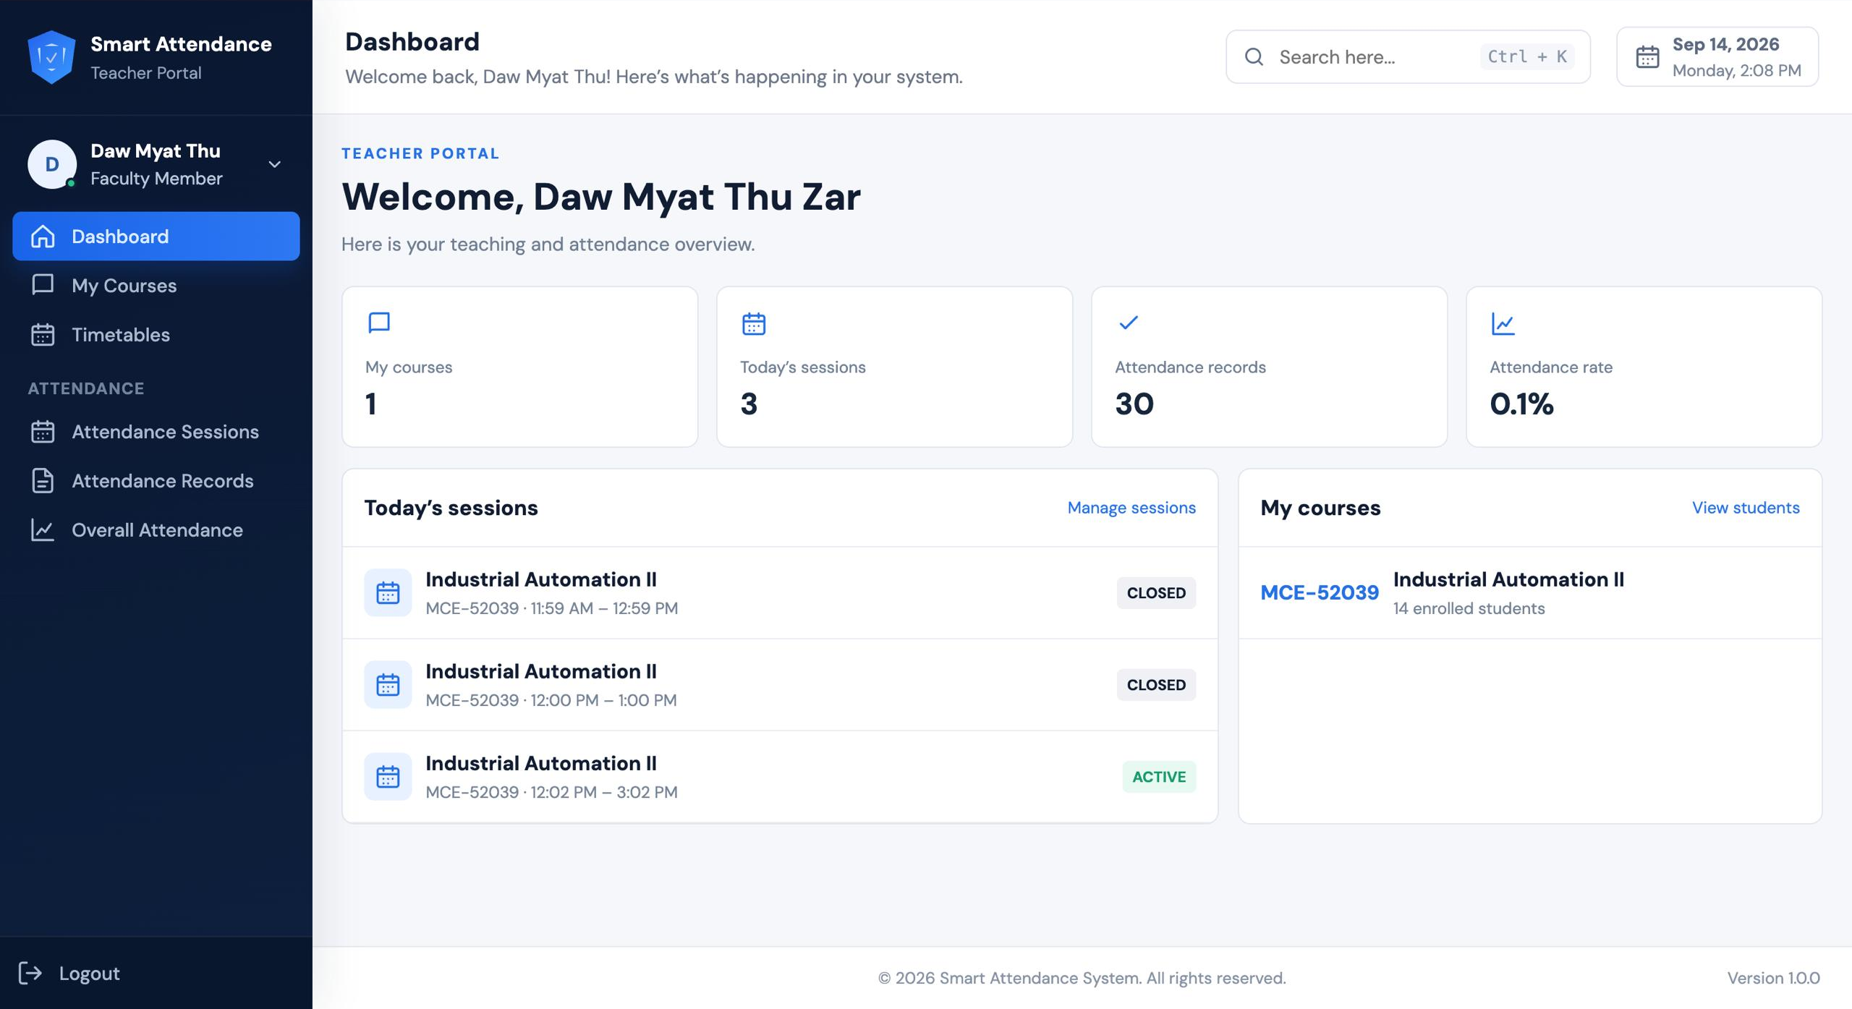
Figure 5.7 Teacher dashboard and assigned-course overview.
Dashboard. The teacher portal summarizes assigned courses, today’s sessions, attendance records, and attendance rate. Session cards show active or closed status. “Manage sessions” and “View students” lead to the relevant management views.
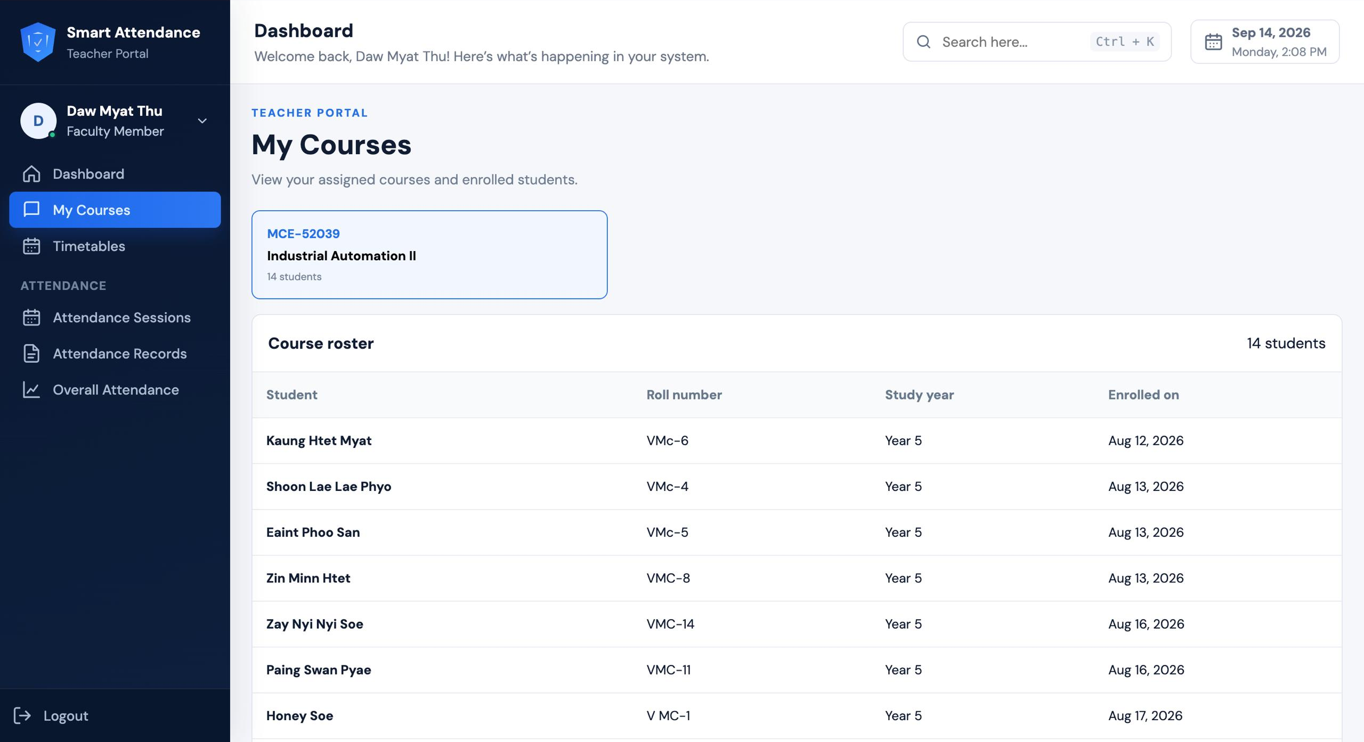
Figure 5.8 My Courses showing the 14-student course roster.
My Courses. Selecting Industrial Automation II opens its roster. The visible result contains student names, roll numbers, study year, and enrollment dates, with a total of 14 students. This allows the teacher to check who is enrolled before reviewing attendance. The dashboard provides a quick teaching overview, while the roster identifies individual students in the selected course. Together, these views help the teacher relate session information to the correct class list before examining record.

5.4.1 Timetable Management
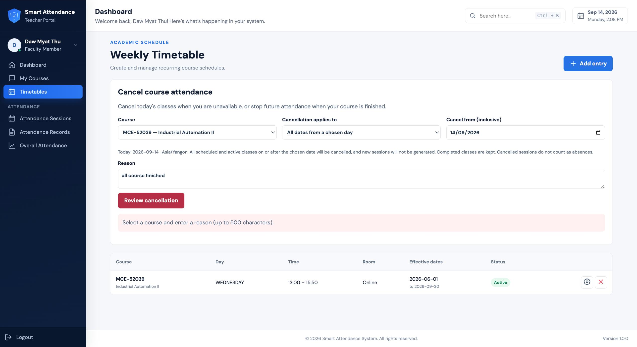
Figure 5.9 Teacher timetable and course-cancellation controls.
Timetables displays recurring class schedules. The teacher can review the day, time, room, effective dates, and active status. The cancellation controls specify the affected course, dates, and reason; cancelled sessions are excluded from absence counting. The screenshot shows the form, not proof of a completed cancellation submission.
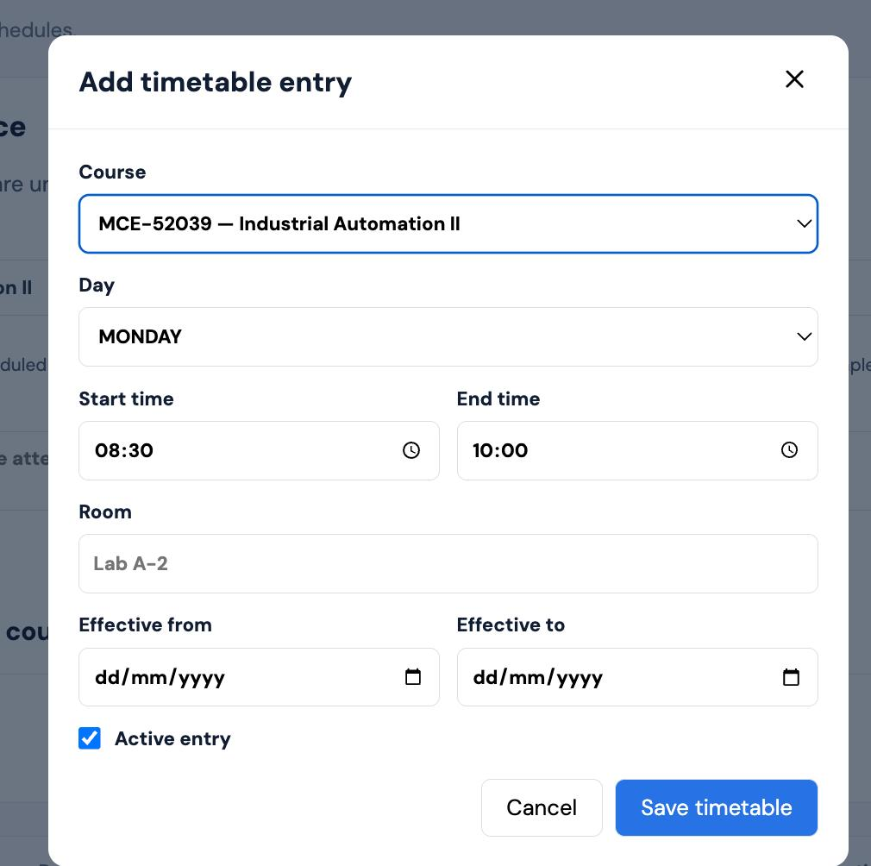
Figure 5.10 Add timetable entry dialog.
Selecting “Add entry” opens the dialog above. The teacher specifies a course, weekday, start and end times, room, effective date range, and active status, then saves the timetable. This separates a recurring schedule from a one-time manually created session.

5.4.2 Attendance Session Management
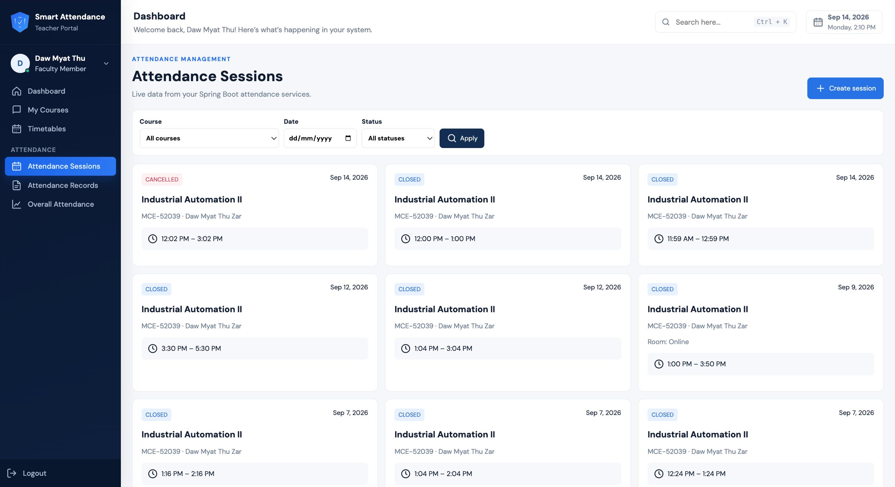
Figure 5.11 Teacher attendance-session list and filters.
Attendance Sessions provides course, date, and status filters. The displayed cards include closed and cancelled sessions with their course and time information. These status labels distinguish completed classes from cancelled attendance opportunities.
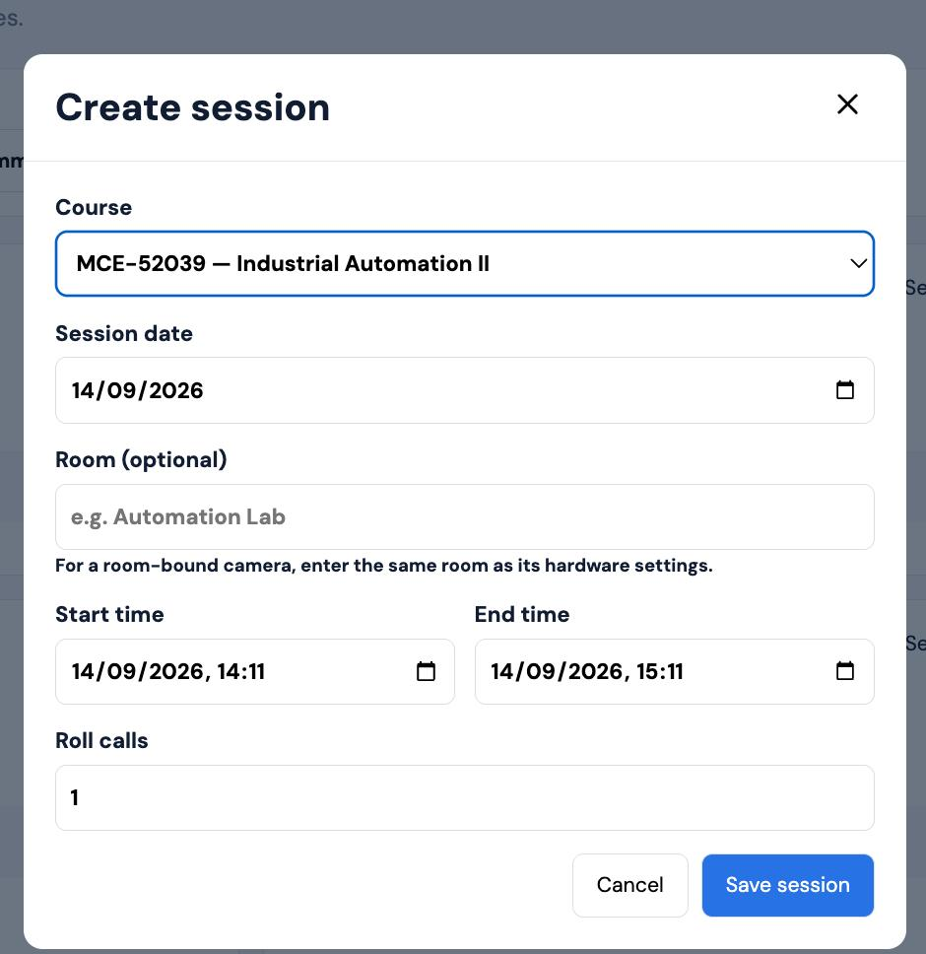
Figure 5.12 Create session dialog for a manual class.
Selecting “Create session” opens a form for the course, session date, room, start and end times, and number of roll calls. For a room-bound camera, the same room must be entered as in the hardware settings. “Save session” submits the manual class for attendance processing. Manual session creation allows the teacher to arrange an additional class without changing the recurring timetable.

5.5 Teacher Attendance Reports

5.5.1 Attendance Records and Individual-Course Output
Attendance Records is the teacher’s route to reviewing recorded attendance and filtered report data. The reporting service supports PDF and Excel exports for course-filtered attendance reports. PDF is suitable for a fixed print copy, while Excel supports further review, sorting, and institutional reporting.
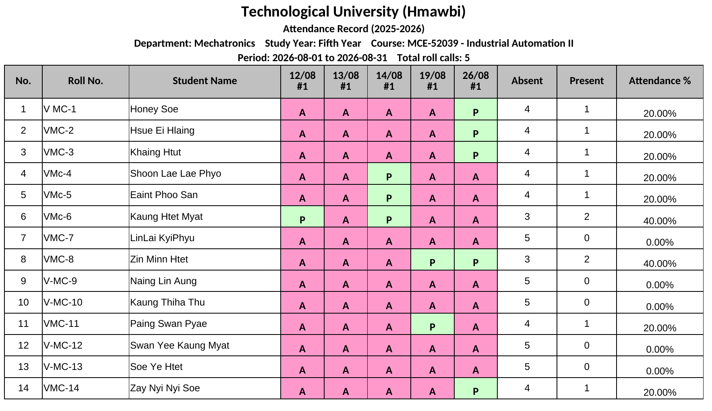
Figure 5.13 Individual-course Excel export, shown in its print layout.
The exported Industrial Automation II register covers 1–31 August 2026. It contains 14 students and five roll calls. Each student has dated P/A entries, absent and present totals, and an attendance percentage. For example, roll number VMc-6 has two present entries out of five roll calls, giving 40.00%, which agrees with the displayed report.
The register can be retained as Excel data or issued as a PDF report. This illustration is the downloaded workbook’s print layout, not a newly downloaded website PDF.

5.5.2 Overall Attendance Function
Overall Attendance combines each student’s results across enrolled courses. The teacher can filter by study year, reporting period, reference date, and student search. The downloaded overall workbook shown on the next page contains the same 14-student cohort and seven subject columns, followed by a combined attendance value and a remarks field.5.5.3 Overall Report Output
The overall export is dated 14 September 2026 and uses the university report layout. It includes student identities, subject percentages, a Total column, and preparation and approval areas. The report is intended for reviewing the class across subjects, rather than only one teacher’s course.
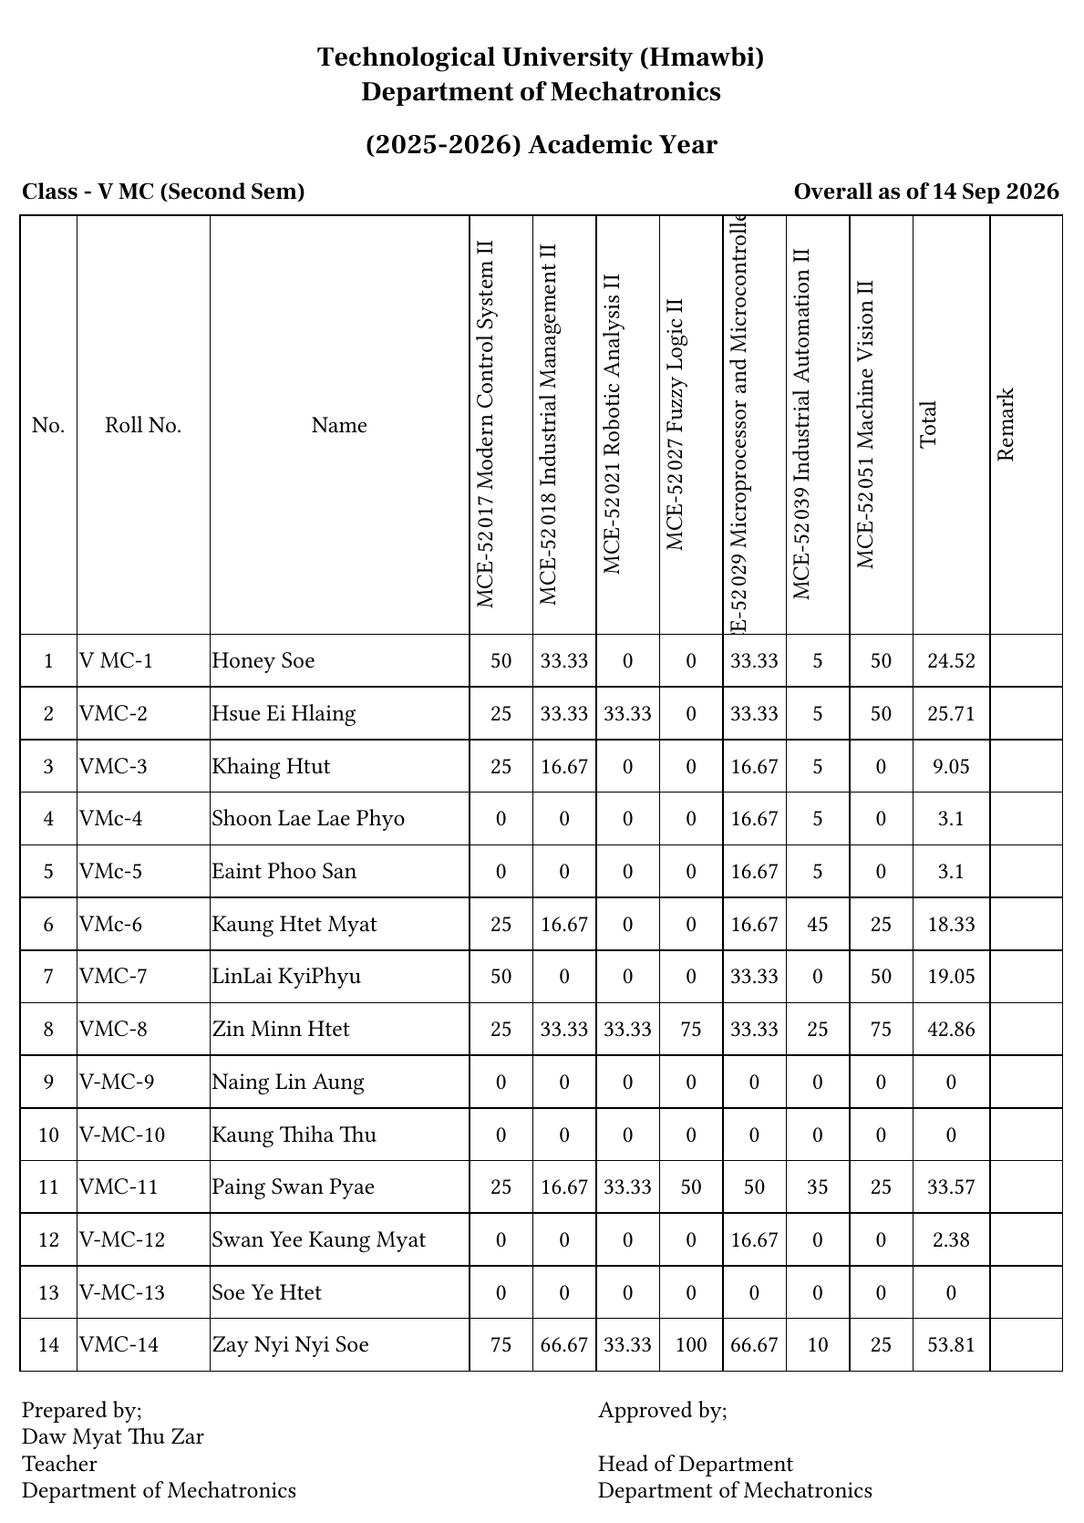
Figure 5.14 Overall attendance Excel export for 14 students across seven subjects.
Each row links a student’s roll number and name to the attendance percentages for the seven subjects.

5.5.4 PDF and Excel Output Interpretation
Teachers obtain individual-course and combined attendance reports. Excel retains values for review; PDF provides a fixed print copy. The current overall interface offers a direct Excel download. Its workbook can be exported or printed to PDF in a spreadsheet application; a direct overall-PDF download from the website was not established.
VMc-6 has 18.33% overall attendance in both the dashboard and the overall report. The seven subject values—25, 16.67, 0, 0, 16.67, 45, and 25—average approximately 18.33%. This cross-check links the student and teacher outputs. The August course register and September overall report cover different periods.

5.6 Administrator Dashboard and Functions
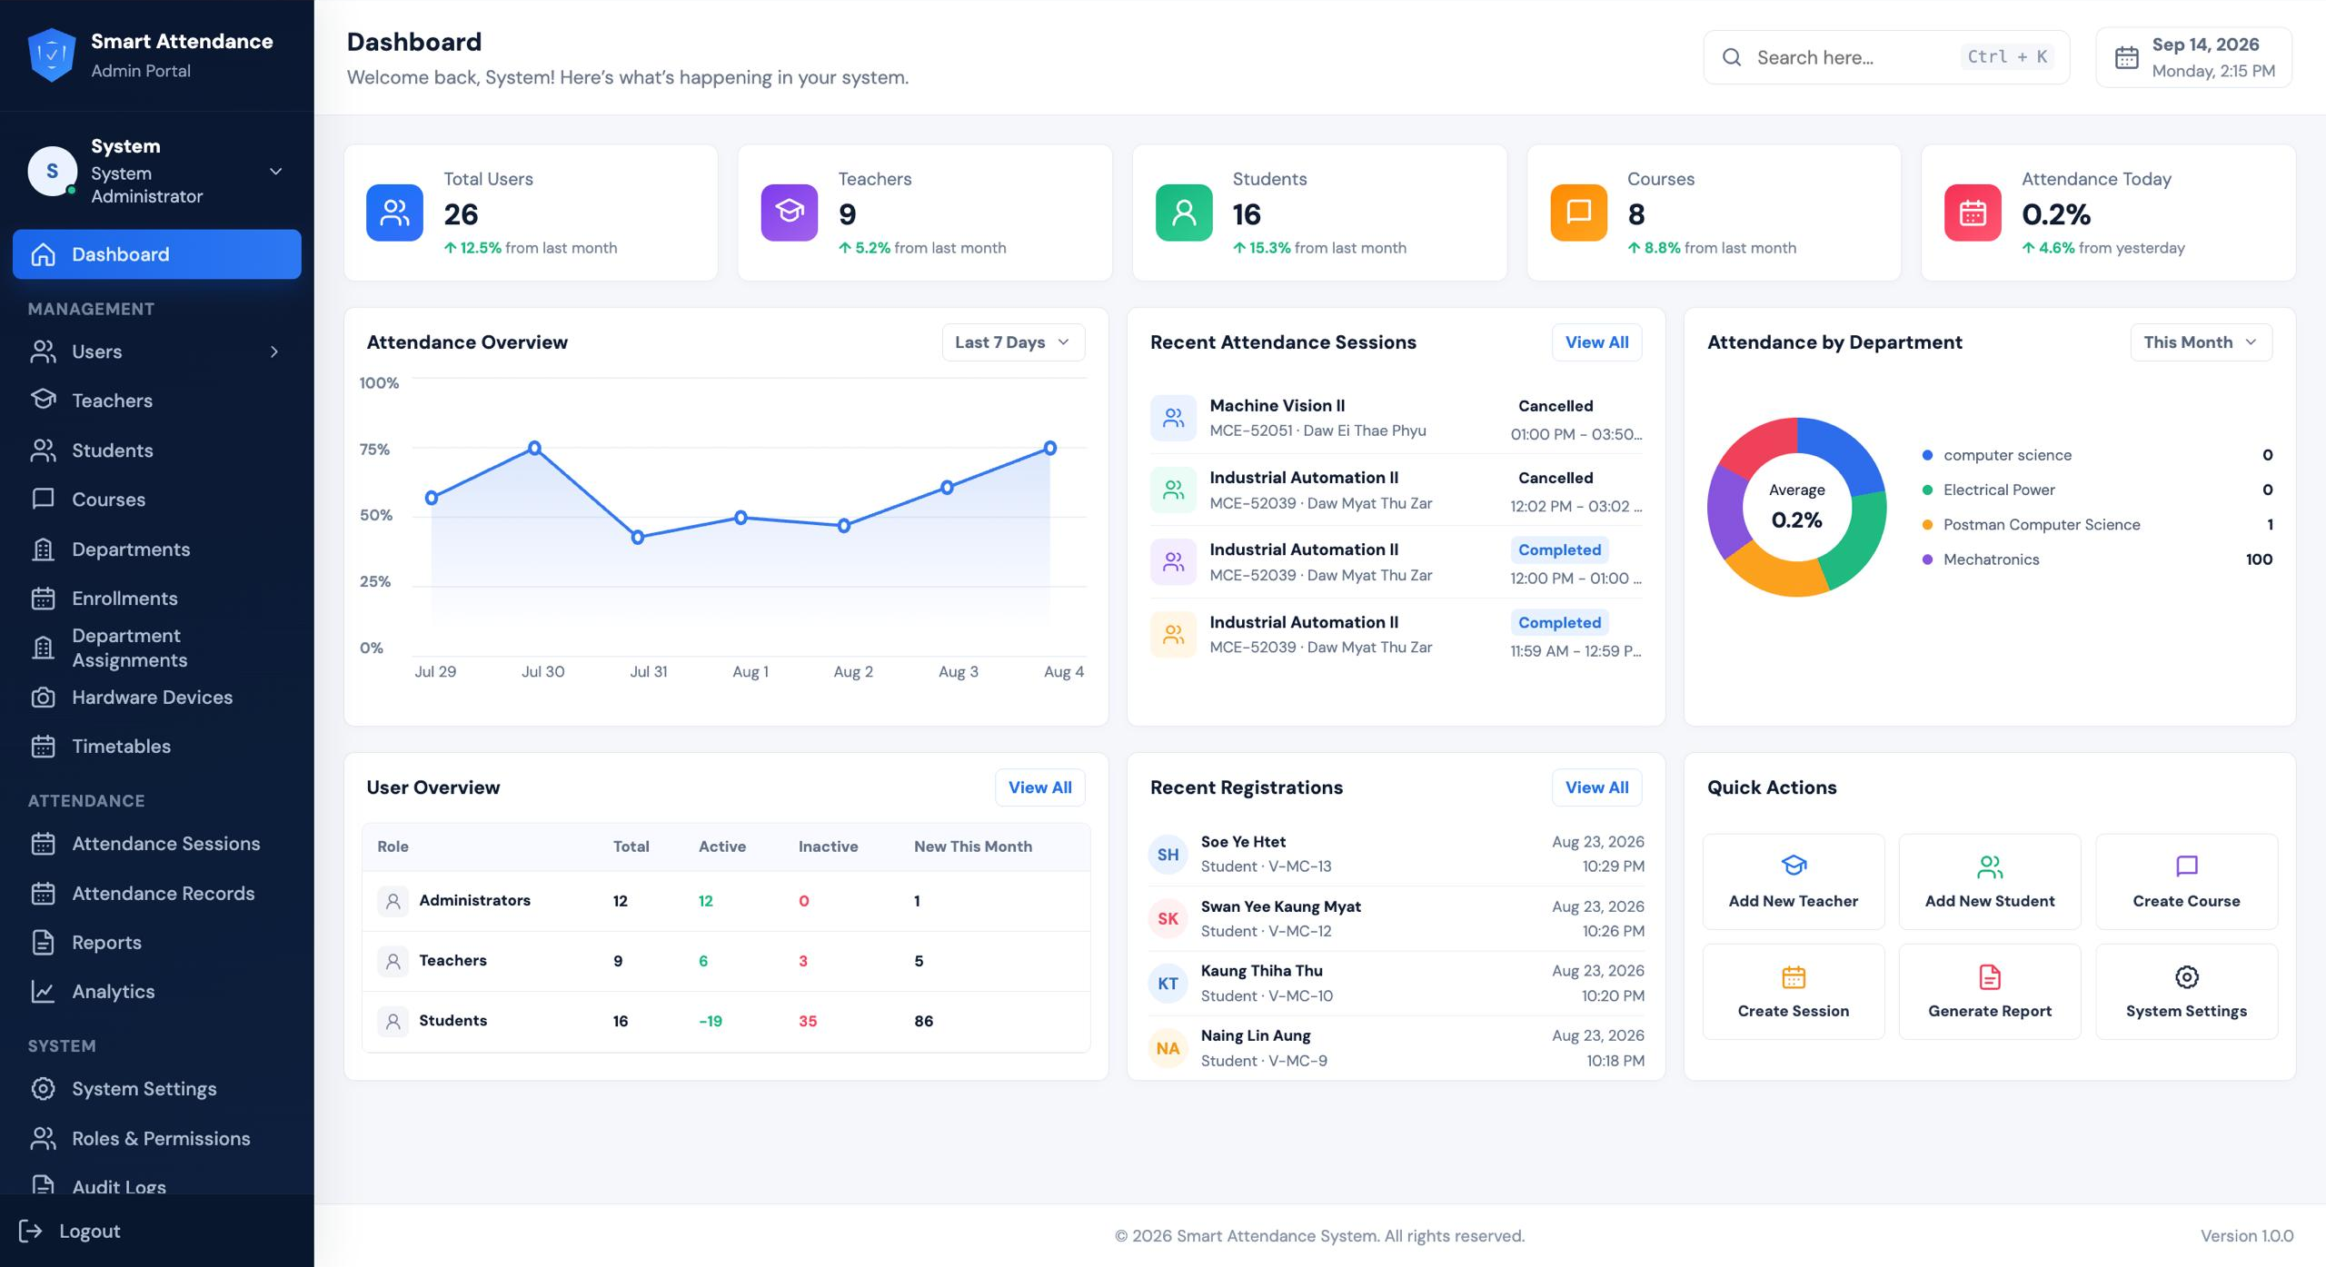
Figure 5.15 Administrator dashboard and management navigation.
The administrator dashboard provides an overview of users, academic records, recent sessions, registrations, and quick actions. Only this dashboard screenshot is used for the administrator; the individual functions are described below. Whole-system account totals are distinct from the 14-student evaluation cohort, so the dashboard’s student-account count is not used as the number of trained participants.
Users, Teachers, and Students. These areas organize user accounts and role-specific academic identities. Teachers are associated with teaching information, while student records hold roll numbers, study years, and department details needed for enrollment and attendance.

5.6.1 Administrator Function Descriptions
Courses. Maintains course codes, titles, and academic associations so that timetables, enrollments, sessions, and reports refer to the correct subject.
Departments. Organizes academic departments used to group teachers, students, courses, and reporting data.
Enrollments. Links students to courses. These links determine the relevant class roster and attendance opportunities for each student.
Department Assignments. Manages departmental academic assignments used to organize teaching responsibilities and academic access.
Hardware Devices. Registers attendance cameras, assigns device identifiers and authentication keys, and configures room and optional course binding. Devices can be enabled or disabled; room values must agree with the sessions that the camera is expected to find.
Timetables. Maintains recurring class days, time ranges, rooms, effective dates, and active status for scheduled attendance processing.
Attendance Sessions. Reviews and manages class attendance windows, including manually created sessions and their active, closed, or cancelled states.
Attendance Records. Reviews stored attendance entries and the associated student, course, session, verification time, and recognition information.
Reports. Provides filtered attendance outputs for academic review and PDF or Excel export where supported by the selected report.
Analytics. Provides a navigation area for examining attendance summaries and trends. The dashboard chart values are interface snapshots and are not treated here as a measured evaluation of recognition performance.
System Settings, Roles & Permissions, and Audit Logs. These areas concern configuration, access control, and activity review. Their menu entries are visible, but individual configuration and audit operations are not demonstrated by the dashboard screenshot.
Quick Actions and Logout. Quick actions provide shortcuts to common tasks such as adding academic users, creating a course or session, and generating a report. Logout ends the current user’s portal session.

5.7 Discussion of the Test Results
The screens document the workflow from student login and face capture to teacher rosters and attendance reports. The exports provide identifiable student rows, reporting periods, and attendance calculations, linking interface activity to usable academic output.
Cohort result. The system was prepared using 14 registered/trained classmates. The teacher’s course roster and the downloaded registers show 14 students. The overall report contains seven subject columns for that cohort.
Recognition result. The demonstrated scan returned an already-recorded response with 77% similarity. This supports the observed verification and duplicate-feedback workflow for that attempt. It does not establish the recognition accuracy of all 14 students or the success rate under different lighting conditions.
Reporting result. The course register preserves dated present/absent entries and percentage totals. The overall workbook consolidates subject percentages in the university layout. A sampled student’s 18.33% overall value agrees between the dashboard and the overall export.
Scope of the evidence. The screenshots show particular interface states and available controls. Opening a form is evidence of the interface, not proof that every save, filter, permission rule, or error path passed a test. The photographs establish hardware construction, while separate recorded trials would be needed for hardware capture reliability and timing.

5.8 Chapter Summary
The results illustrate a three-role attendance system prepared with 14 registered/trained students. Students verify attendance and review academic information; teachers manage classes and obtain reports; administrators organize accounts, academic data, and devices. The key outputs are individual-course and combined registers, retained in Excel or issued as PDF through the supported report or print workflow.
These results support the system’s use as an integrated attendance-management prototype. Further evaluation should record repeated genuine and non-matching face attempts, hardware operation under classroom conditions, and complete export checks for the required report formats before making quantitative reliability or recognition-accuracy claims.

